**Chapter 1**

**Integration**

**1.5. Substitution**

**Section Exercises**

255. If  when reversing the chain rule,  should you take  or ?

Answer: 

**In the following exercises, verify each identity using differentiation. Then, using the indicated *u*-substitution, identify *f* such that the integral takes the form .**

257.  

Answer: 

259. ; 

Answer: ; 

**In the following exercises, find the antiderivative using the indicated substitution.**

261. ; 

Answer: 

263. ; 

Answer: 

265. ; 

Answer: 

267. ; 

Answer: 

269. ;  (*Hint:* )

Answer: 

**In the following exercises, use a suitable change of variables to determine the indefinite integral.**

271. 

Answer: 

273. 

Answer: 

275. 

Answer: 

277. 

Answer: 

279. 

Answer: 

281. 

Answer: 

283. 

Answer: 

285. 

Answer: 

287. 

Answer: 

**In the following exercises, use a calculator to estimate the area under the curve using left Riemann sums with 50 terms, then use substitution to solve for the exact answer.**

289. **[T]**  over 

Answer:  The exact area is 

291. **[T]** over 

Answer: … The exact area is 0.

**In the following exercises, use a change of variables to evaluate the definite integral.**

293. 

Answer: , , 

295. 

Answer: , , 

297. 

Answer: , , 

**In the following exercises, evaluate the indefinite integral  with constant  using *u*-substitution. Then, graph the function and the antiderivative over the indicated interval. If possible, estimate a value of *C* that would need to be added to the antiderivative to make it equal to the definite integral , with *a* the left endpoint of the given interval.**

299. **[T]**  on 

Answer:

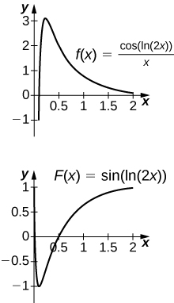

The antiderivative is . Since the antiderivative is not continuous at , one cannot find a value of *C* that would make  work as a definite integral.

301. **[T]**  over 

Answer:

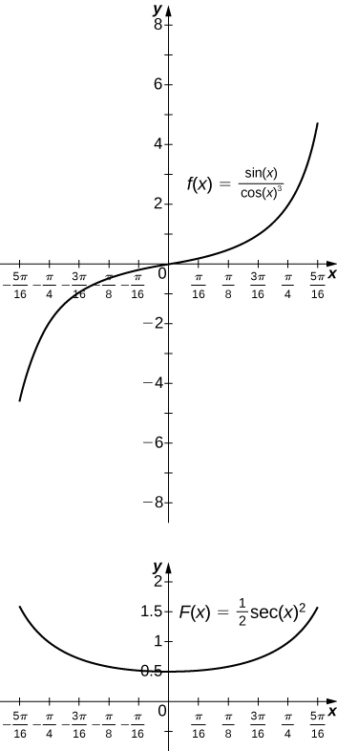

The antiderivative is . You should take  so that .

303. **[T]**  over 

Answer:

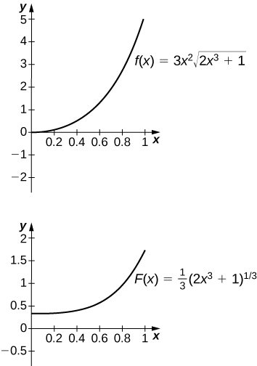

The antiderivative is . One should take .

305. Is the substitution  in the definite integral  okay? If not, why not?

Answer: No, because the integrand is discontinuous at .

**In the following exercises, use a change of variables to show that each definite integral is equal to zero.**

307. 

Answer: ; the integral becomes .

309. 

Answer: ; the integral becomes .

311. 

Answer: ; the integral becomes



since the integrand is odd.

313. Show that the average value of  over an interval  is the same as the average value of  over the interval  for .

Answer: Setting  and  gets you .

315. Find the area under the graph of  between  and , where  and  is fixed. Evaluate the limit as .

Answer:  As  the limit is  if , and the limit diverges to +∞ if .

317. The area of the top half of an ellipse with a major axis that is the *x*-axis from  to *a* and with a minor axis that is the *y*-axis from  to *b* can be written as . Use the substitution  to express this area in terms of an integral of a trigonometric function. You do not need to compute the integral.

Answer: 

319. **[T]** The following graph is of a function of the form . Estimate the coefficients *a* and *b* and the frequency parameters *n* and *m*. Use these estimates to approximate .

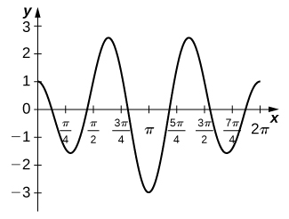

Answer: ; 

This file is copyright 2016, Rice University. All Rights Reserved.